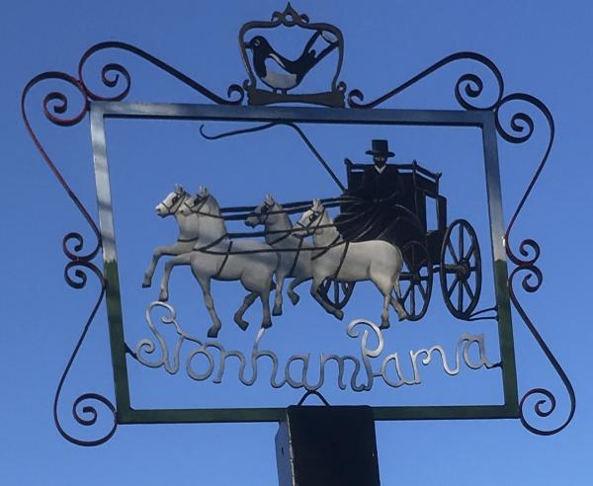
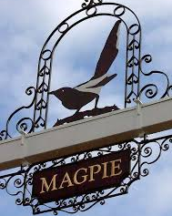
STONHAM PARVA
PARISH COUNCIL

Parish Council meeting to be held at 7.30 p.m. on Monday 9th November 2020 for the purpose of transacting the following business.
Filming, photography, recording or reporting of the meeting is permitted. 2nd November 2020

PUBLIC PARTICIPATION – Should any Parishioner wish to speak on any item on the agenda, please be available by 7.30 p.m.

PLEASE NOTE THIS MEETING WILL BE HELD AS A REMOTE MEETING ON THE ZOOM MEETING PLATFORM

A G E N D A

- Apologies
- To receive Councillors’ Declarations of Interest in any item on the Agenda
- To receive any dispensations
- To confirm & sign minutes of the Parish Council meeting 12th October 2020
- Covid-19
- Reports
a) County Councillor - Matthew Hicks
b) District Councillor - Mrs Suzie Morley
c) Footpaths
d) Cemetery
e) Play Area
- Certificate
- Statutory Declaration
f) Neighbourhood Watch
g) Tree Warden
h) SALC
- Communication
- Quiet Lane – Clockhouse Lane
- Planning including Applications
- Training/Conferences
- Finance
- Budget Review (6 months)
- Governance
- Standing Orders
- Defibrillator
- Village Sign
- St Marys Church
- Remembrance Sunday
- Fundraising
- St Marys Church
- Correspondence
- Review of actions not otherwise covered above
- Date of next Meeting – Monday 14th December 2020

If you wish to participate in this meeting the details for Zoom are:

https://us02web.zoom.us/j/87006757440?pwd=T3RtM1hOM0plcXk1THovQ2NUUEkzdz09

Meeting ID: 870 0675 7440

Passcode: 058098

Alternatively, if you are unable to attend virtually please contact the Clerk regarding any issues you would like

