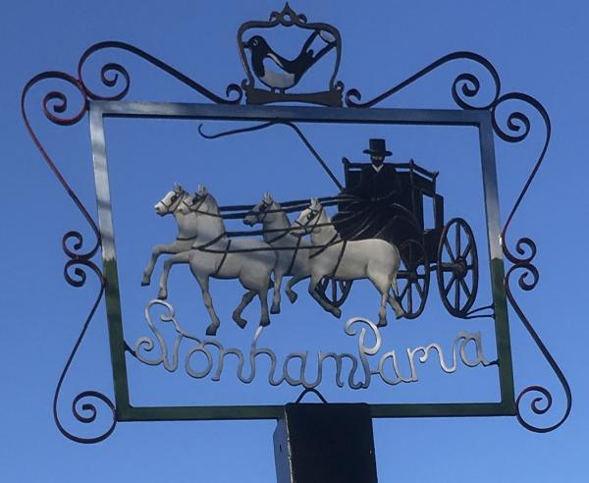
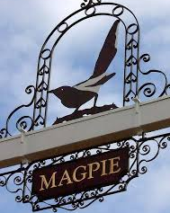
STONHAM PARVA
PARISH COUNCIL

Parish Council meeting to be held at 8pm on Monday 19th April 2021 for the purpose of transacting the following business. (PLEASE NOTE CHANGE OF TIME)
Filming, photography, recording or reporting of the meeting is permitted 14th April 2021

PUBLIC PARTICIPATION – Should any Parishioner wish to speak on any item on the agenda, please be available by 8pm. PLEASE NOTE THIS MEETING WILL BE HELD AS A REMOTE MEETING ON THE ZOOM MEETING PLATFORM

A G E N D A
- Apologies
- To receive Councillors’ Declarations of Interest in any item on the Agenda
- To receive any dispensations
- To confirm & sign minutes of the Parish Council meeting 8th March 2021
- Covid-19
- Reports
a) County Councillor - Matthew Hicks
Please note new data Monday 19th April 2021
b) District Councillor - Mrs Suzie Morley
c) Footpaths
d) Cemetery
e) Play Area – request to metal detect
f) Neighbourhood Watch
g) Tree Warden
h) SALC
- Communication – noticeboard decision
- Planning Applications – Mowness Hall Farm
- Training/Conferences
- Finance – AGAR Accounting Report & Grass Cutting Contract
- Governance – AGAR Governance Statement
- Playing Field – Boundary issue
- Village Sign
- Safety Concerns A140
- Fundraising
- Correspondence
- Review of actions not otherwise covered above
- Date of Annual Parish Meeting
- Dates of meetings
- Date of next Meeting – TBC

Join Zoom Meeting
https://us02web.zoom.us/j/89607649183?pwd=b0VXVHBmQjVYMlc4S21hdG9oYml6Zz09

Meeting ID: 896 0764 9183 Passcode: 231673

Alternatively, if you are unable to attend virtually, please contact the Clerk regarding any issues you would like.

